Group B Case Study: Outland Adventures
Michael Gordon, Michael Benko, Jacob Richman
Bellevue University
Database Development and Use CSD310
Professor: Dr. Mortoza Abdullah
09/26/2026

Contents
Python Code: 2
Printout From Database: 3
Revised ERD: 7

Python Code:
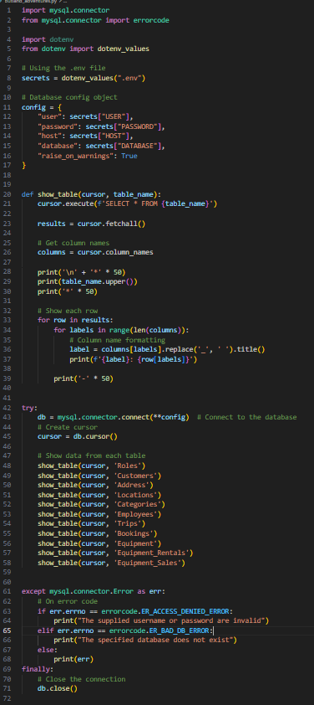

Printout From Database:
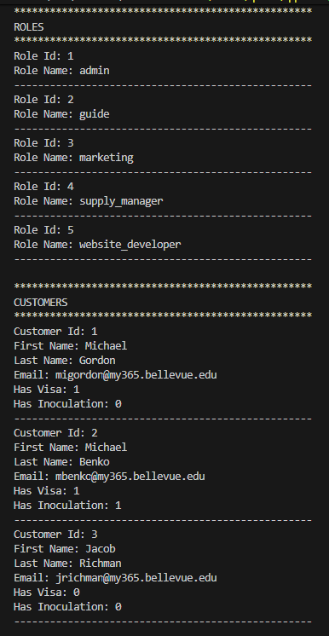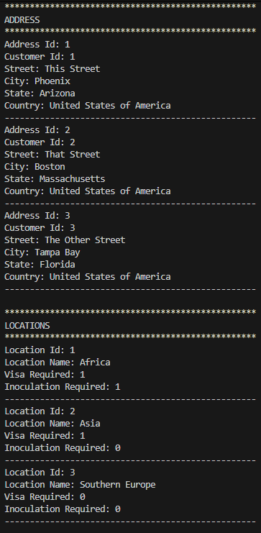
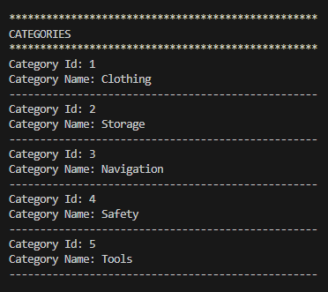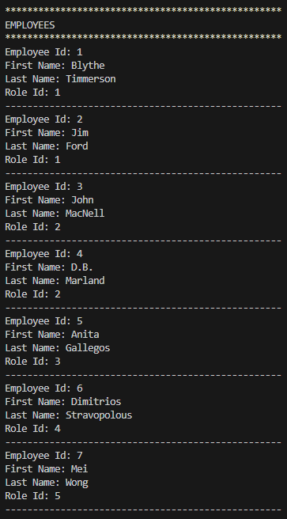
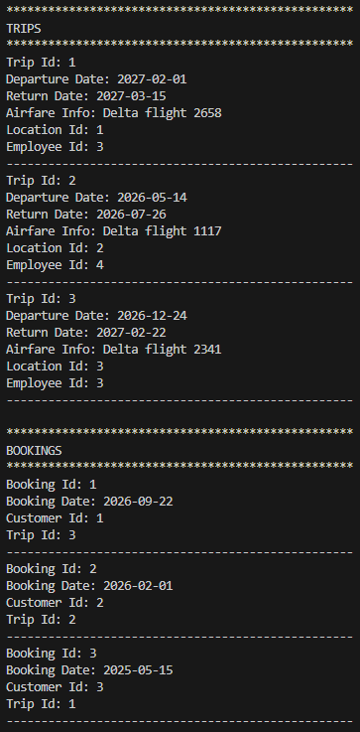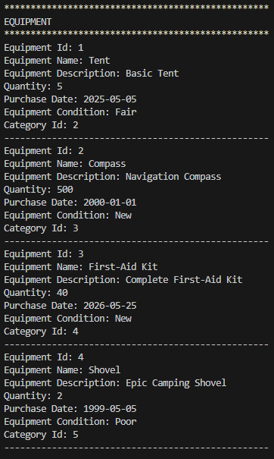
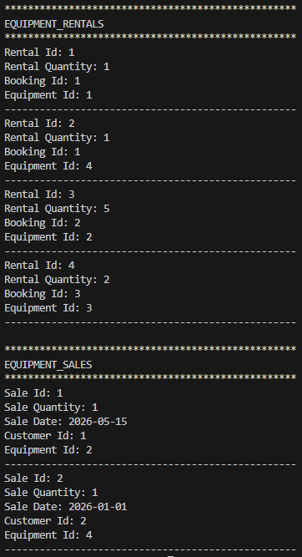

Revised ERD:
